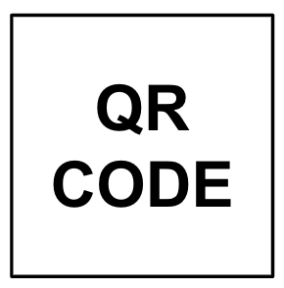
4
100X Inactivation Solution  Lot (-MMDD):  Freeze EXP (MM-YY):  Thaw EXP (+3 months):  Put New in Use:  Location: Name:  Date and Time: |  |  |  | Log Link: SOP-101-B_1 {SITE}  Name:  Date and Time:

1X Inactivation Saline Solution Prep Protocol:
- Vortex 100X Inactivation Solution for 10 sec.
- Add 1/100 volume of 100X Inactivation Solution to Saline.
- Vortex for 10 sec, Invert 3 times, and Vortex for 10 more sec.
* If making Inactivation Solution in a bottle, shake instead of vortexing
- Label tube with 1XISS ID (1X_MMDD-1).
- EXPIRATION of 1X Inactivation Saline Solution: 2 weeks after prep.

Name | Date + Time | 1XISS ID  (1X_MMDD-1) | Saline  Lot + Exp | Saline  mL | 100XISS  µL

Name | Date + Time | 1XISS ID  (1X_MMDD-1) | Saline  Lot + Exp | Saline  mL | 100XISS  µL

